**Assignment 1.3**

**Linux commands :**

**PWD:** Print Working Directory

It writes the full path name of the current working directory to the output file.

Syntax : pwd

**Vi:**

Vi is an interactive text editor which is display oriented. The screen of our terminal act as a window into the file we are editing.

Syntax : vi filename

**Touch:**

It changes the file timestamp. ‘touch’ command is also used to create a file and If the file already exist then it changes the time stamp. There are several related terms are.

**-a ==** Changes the access time.

**-c ==** If the file does not exist, do not create it.

**-d ==** update the access and modification time

**-m ==** Changes the modification time only

**-r ==** Use the access and modification time of another file to the working file.

**-t ==** Create a file using the specified time.

Syntax: touch filename

touch –c –t YYDDHHMM file1

touch –r file1 file2

**mkdir :**

Used to create a new folder or a directory.

Syntax : mkdir filename

**rm:**

Used to remove the file.

Syntax : rm filename

**ls:**

List the files and directories present in the current working directory.

Syntax: ls

**echo:**

Echo command os used to display the contents followed by ‘echo’.

Syntax : echo sometext

**cat:**

concatenate and print on the standard output. The general syntax is cat followed by the filename , It will display the contents on the file specified.

Syntax: cat filename

This cat can also be used to display the multiple files.

Syntax : cat file1 file2 file3

Create a file with the cat command.

Syntax: cat >file1

**who:**

Print all usernames currently logged in.

Syntax: who

**cd:**

To change the directory of the file we use cd command.

Syntax: cd directoryName.

**date:**

Used to display the present date & time. Here we can change our date and time accordingly.

Syntax: date

date “+DATE : %m/%d/%y%nTime : %H%M%S”

It will display the the date in DATE : 02/03/2017

TIME : 16:44:30

**cal:**

This will display the calendar of a given month and year.

Syntax: cal (display current month)

cal 8 1947 (display specified month)

**mv:**

This move command is used to move a file ont to another. It can move or rename files or directories.

Syntax: mv source target

**cp:**

Copy one or more files to another location.

Syntax: cp source target

**which:**

Locate the program files in the users path. It allows the user to pass several command names as arguments to get their path in the system.

Syntax: which name

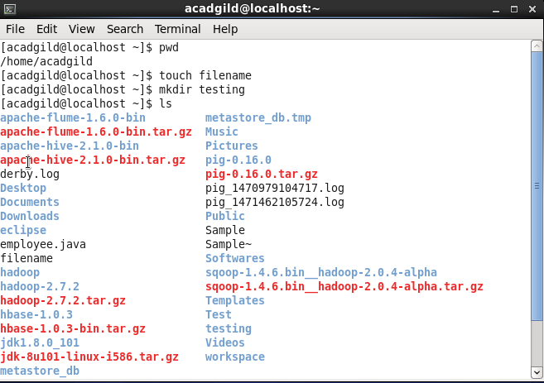

The directory testing has been created. And below screenshot displays the folder where the “filename” is created using the ‘touch’ command.

